 | Course Name: Design Patterns/Thinking LAB | EXPERIMENT NO. 9
 | Course Code: 20CP210P  Faculty: Dr. Payal Chaudhari | Branch: CSE | Semester: IV
(To be filled by Student)
Submitted by: Meet Jain
Roll no: 23BCP093

Objective: To familiarize students with standard Structural design patterns.
Experiment: Explain the Flyweight Design Pattern and write a program using any object-oriented programming language to demonstrate the working of Flyweight Design Pattern.

Code:
import javax.swing.*;
import java.awt.*;
import java.awt.event.MouseAdapter;
import java.awt.event.MouseEvent;
import java.util.HashMap;
import java.util.Map;
import java.util.Random;

interface Shape {
void draw(Graphics g, int x, int y, int size, Color color);
}

class Line implements Shape {
@Override
public void draw(Graphics g, int x, int y, int size, Color color) {
g.setColor(color);
g.drawLine(x, y, x + size, y + size);
}
}

class Rectangle implements Shape {
@Override
public void draw(Graphics g, int x, int y, int size, Color color) {
g.setColor(color);
g.fillRect(x, y, size, size + 20);
}
}

class Square implements Shape {
@Override
public void draw(Graphics g, int x, int y, int size, Color color) {
g.setColor(color);
g.fillRect(x, y, size, size);
}
}

class Circle implements Shape {
@Override
public void draw(Graphics g, int x, int y, int size, Color color) {
g.setColor(color);
g.fillOval(x, y, size, size);
}
}

class ShapeFactory {
private static final Map<String, Shape> shapeMap = new HashMap<>();

public static Shape getShape(String type) {
Shape shape = shapeMap.get(type);

if (shape == null) {
switch (type) {
case "LINE" -> shape = new Line();
case "RECTANGLE" -> shape = new Rectangle();
case "SQUARE" -> shape = new Square();
case "CIRCLE" -> shape = new Circle();
}
shapeMap.put(type, shape);
}
return shape;
}
}

public class DrawingApp extends JFrame {
private final Random random = new Random();

public DrawingApp() {
setTitle("Flyweight Drawing App");
setSize(800, 600);
setDefaultCloseOperation(JFrame.EXIT_ON_CLOSE);
setLocationRelativeTo(null);

JPanel canvas = new JPanel() {
@Override
protected void paintComponent(Graphics g) {
super.paintComponent(g);
}
};

canvas.addMouseListener(new MouseAdapter() {
@Override
public void mouseClicked(MouseEvent e) {
Graphics g = canvas.getGraphics();
String[] shapes = {"LINE", "RECTANGLE", "SQUARE", "CIRCLE"};
String shapeType = shapes[random.nextInt(shapes.length)];
Shape shape = ShapeFactory.getShape(shapeType);

int size = random.nextInt(50) + 20;
Color color = new Color(random.nextInt(256), random.nextInt(256), random.nextInt(256));

shape.draw(g, e.getX(), e.getY(), size, color);
}
});

add(canvas);
}

public static void main(String[] args) {
SwingUtilities.invokeLater(() -> new DrawingApp().setVisible(true));
}
}

Output:
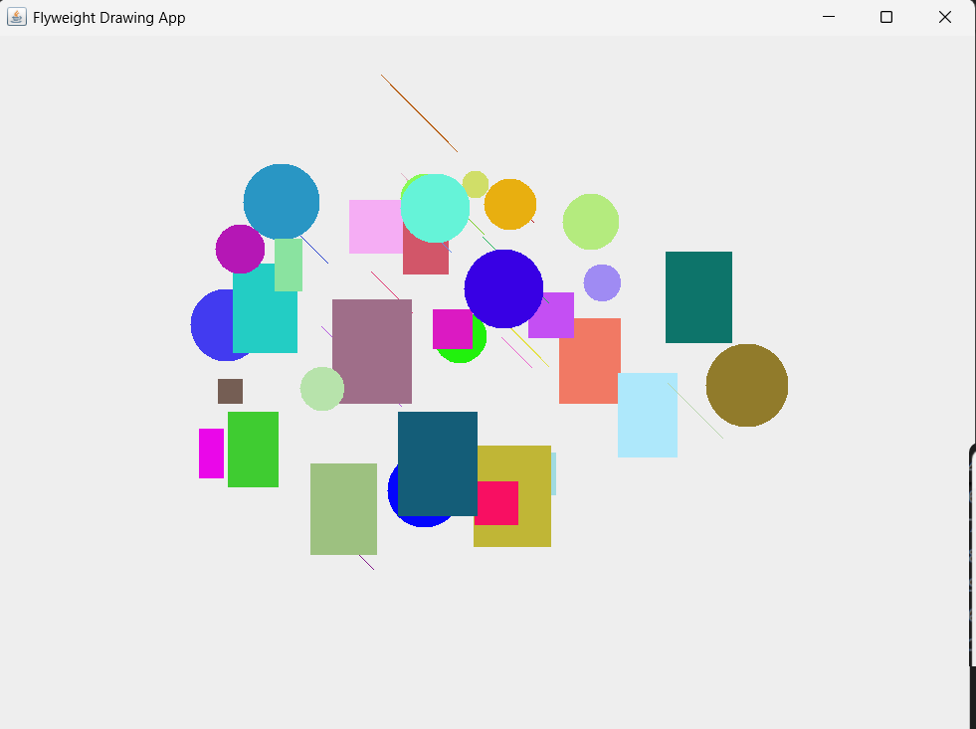

Class Diagram:

